 |  |  | WEDNESDAY | THURSDAY | FRIDAY | SATURDAY
 |    |  | 1st  10:30 – 11:30am    Chapel  1:30 – 3:00pm  BINGO    3:00 – 3:30pm    Book Club | 2nd  10:30 – 11:30am  Scenic Bus Trip  10:30 – 11:00am  Chair Exercises  11:00 – 11:30am    Newspaper Reading  2:00 – 3:00pm  Anne Battams Community Singalong in the Chapel  3:30 – 5:00pm    Ballroom Dance Class at Loxton Retirement Village Community Centre | 3rd  10:30 – 11:30am  Join us to watch the 1951 Disney version of Alice in Wonderland in the Edwards Recreation Room  10:30 – 11:30am  Community Connection Outing  to Loxton RSL  2:00 – 3:30pm  Alice in Wonderland Mad Hatters Tea Party   | 4th  10:45 – 11:15am    Chair Yoga  11:15 – 12pm    Hookey / Quoits  1:30 – 3:30pm  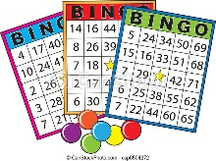    BINGO
SUNDAY | MONDAY | TUESDAY | WEDNESDAY | THURSDAY | FRIDAY | SATURDAY
5th Naidoc Week  10:45 – 12pm  Lutheran Church service DVD in the Edwards Rec Room    1:30 – 3:30pm    Mindfulness Colouring with Dakota | 6th Naidoc Week  10:30 – 11:00am  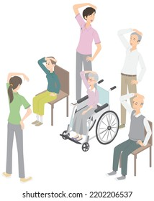  Chair Exercises  11:00 – 11:30am  JBall Hockey  1:30 – 2:30pm  Julie Noble Live in Concert  3:30 – 4:30pm  Mingle with Maxine | 7th Naidoc Week  10:30 – 11:00am  Short Walking Group  11:00 – 11:30am  Long Walking Group  (weather permitting)    11:00 – 11:30am    1:1 Footy Tipping  1:30- 3:30pm    Monthly Birthday Celebrations!! | 8th Naidoc Week  10:00 – 11:00am  Naidoc Week Outing – Flag Raising & Morning Tea at Loxton Rotunda    10:30 – 11:30am  Chapel    1:30 – 3:00pm  BINGO  3:00 – 3:30pm  Book Club | 9th Naidoc Week  10:30 – 11:30am  Loxton Library Visit  10:30 – 11:00am  Chair Exercises  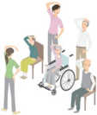  11:00 – 11:30am  Newspaper Reading  2:00 – 3:00pm  Anne Battams    Community Singalong in the Chapel | 10th Naidoc Week  10:30 – 11:30am  Let’s Get Trivial!    1:30 – 3:30pm  Come and Craft with us for NAIDOC Week  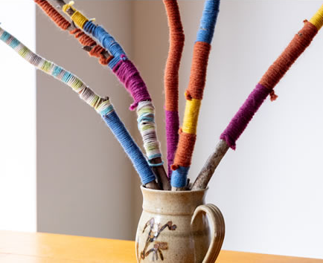 | 11th Naidoc Week  10:45 – 11:15am  Chair Exercises  11:15 – 12pm    Balloon Tennis  1:30 – 3:30pm  BINGO
SUNDAY | MONDAY | TUESDAY | WEDNESDAY | THURSDAY | FRIDAY | SATURDAY
12th  10:45 – 12pm  Lutheran Church service DVD in the Edwards Rec Room  1:30 – 3:30pm    Reminiscing on days gone by… | 13th  10:30 – 11:30am  Chair Exercises  11:00 – 11:30am Seated Soccer    1:30 – 3:00pm    Indoor Bowls  3:30 – 4:30pm  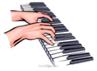  Mingle with Maxine | 14th ^{Bastille Day}  10:30 – 11:00am  Short Walking Group  11:00 – 11:30am  Long Walking Group  (weather permitting)  11:00 – 11:30am  1:1 Footy Tipping  1:00 – 2:00pm  Scenic Bus Trip  2.00 – 3:00pm    Join us for a French Flavours Tasting Board | 15th  10:30 – 11:30am  Chapel  1:30 – 3:00pm  BINGO  3:00 – 3:30pm  Book Club | 16th  10:30 – 11:00am  Chair Exercises  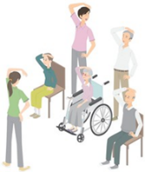  11:00 – 11:30am  Newspaper Reading  2:00 – 3:00pm  Anne Battams Community Singalong in the Chapel | 17th  10:30 – 11:30am  Let’s Get Trivial!  1:30 – 3:30pm  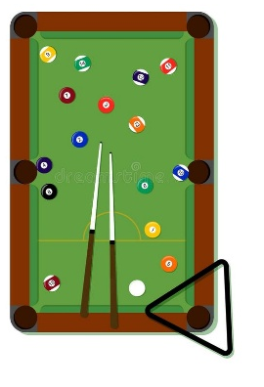  Happy Hour in the Edwards Rec Room | 18th  10:45 – 11:15am  Chair Yoga  11:15 – 12pm  Mini Golf  1:30 – 3:30pm  BINGO
SUNDAY | MONDAY | TUESDAY | WEDNESDAY | THURSDAY | FRIDAY | SATURDAY
19th  10:45 – 12pm  Lutheran Church service DVD in the Edwards Rec Room  1:30 – 3:30pm    Come Experiment with Dakota | 20th  10:30 – 11:30am  Chair Exercises  11:00 – 11:30am  Magnetic Darts    1:30 – 2:30pm  Julie Noble Live in Concert  3:30 – 4:30pm  Mingle with Maxine  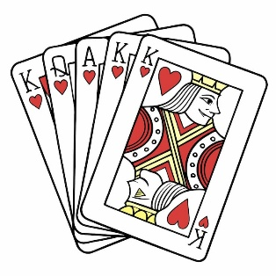 | 21st  10:30 – 11:00am  Short Walking Group  11:00 – 11:30am  Long Walking Group  (weather permitting)  11:00 – 11:30am  1:1 Footy Tipping  1:30 - 3:30pm  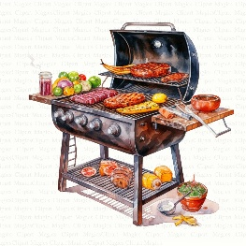  Join us for a BBQ in the Edwards Courtyard | 22nd  10:30 – 11:30am  Chapel  1:30 – 3:00pm  BINGO  3:00 – 3:30pm  Book Club | 23rd  ^{Commonwealth Games}  10:00 - 12:00pm    Paint & Sip - Tea Cups & Saucers at Loxton Retirement Village Community Centre  10:30 – 11:00am  Chair Exercises  11:00 – 11:30am  Newspaper Reading  2:00 – 3:00pm  Anne Battams Community Singalong in the Chapel | 24th ^{Commonwealth Games}  10:30 – 11:30am  Let’s Get Trivial!  10:30 – 11:30am    Jarrod Loxton Art Bus Tour  1:30 – 3:30pm  Yarn a lot    2:30 – 3:15pm  Loxton Lutheran School Worship  Service | 25th  ^{Commonwealth Games}  10:45 – 11:15am  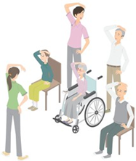  Chair Exercises  11:15 – 12pm    Mini-Basketball  1:30 – 3:30pm  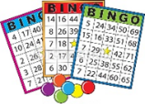  BINGO

SUNDAY | MONDAY | TUESDAY | WEDNESDAY | THURSDAY | FRIDAY
26th  ^{Commonwealth Games}  10:45 – 12pm  Lutheran Church service DVD in the Edwards Rec Room  1:30 – 3:30pm    Games Afternoon | 27th  ^{Commonwealth Games}  10:30 – 11:30am  Chair Exercises  11:00 – 11:30am  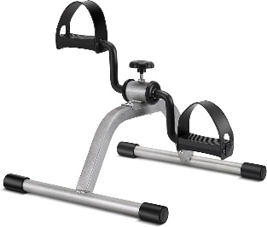  Mini-Bike Pedals  1:30 – 3:00pm  Magic Memories    3:30 – 4:30pm  Mingle with Maxine – Piano Concert | 28th  ^{Commonwealth Games}  10:30 – 11:00am  Short Walking Group  11:00 – 11:30am  Long Walking Group  (weather permitting)  11:00 – 11:30am  1:1 Footy Tipping  1:30- 3:30pm    The Riverview Games | 29th  ^{Commonwealth Games}  10:30 – 11:30am  Chapel  1:30 – 3:00pm  BINGO  3:00 – 3:30pm  Book Club | 30th  ^{Commonwealth Games}  10:30 – 11:00am  Chair Exercises  11:00 – 11:30am  Newspaper Reading  11:00 – 1:00pm  Lunch at The Local    2:00 – 3:00pm  Anne Battams Community Singalong in the Chapel | 31st  ^{Commonwealth Games}  10:30 – 11:30am  Community Coffee Outing  10:30 – 11:30am  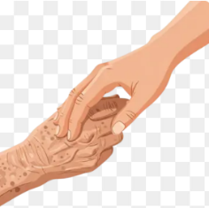  Games Morning with the students from the Loxton High School  1:30 – 2:30pm  Scenic Bus Trip  1:30 – 3:00pm    Crossword Memories

🌿 Find Your Joy 🌿
There’s Something Here at Riverview for Everyone
Did you know there are many lifestyle opportunities available for you to enjoy outside of our leisure and lifestyle program?
You might like to:
☕ Find a quiet spot in the garden to chat and share a cuppa with a friend
🎲 Play a board game
🧩 Work on a puzzle
🎵 Listen to your favourite music
🎬 Watch a movie
📚 Relax in our cosy reading nook
🎱 Enjoy a game of pool
🏓 Have fun with table tennis
🏒 Try air hockey
Your Enjoyment Matters !!
If something interests you — or if you’re looking for something different —
please speak with one of our friendly team members.
We’re here to support you in finding activities that bring comfort, connection and joy.

