SUNDAY | MONDAY | TUESDAY | WEDNESDAY | THURSDAY | FRIDAY | SATURDAY
 | 1st ^{National Reconciliation Week}  10:30 – 11:00am  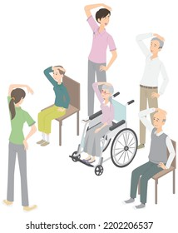  Chair Exercises  11:00 – 11:30am  JBall Hockey  1:30 – 3:00pm  Crossword Memories    3:30 – 4:30pm  Mingle with Maxine and Annelia | 2nd ^{National Reconciliation Week}  10:30 – 11:00am    Short Walking Group (weather permitting)  11:00 – 11:30am    1:1 Footy Tipping  1:30- 3:30pm  Monthly Birthday Celebrations!!   | 3rd ^{MABO DAY}  10:30 – 11:30am    Chapel  1:30 – 3:00pm  BINGO    3:00 – 3:30pm    Book Club | 4th  9:30 – 10:00am  Long Walking Group (weather permitting)  10:30 – 11:30am  Loxton Library Visit  10:30 – 11:00am  Chair Exercises  11:00 – 11:30am    Newspaper Reading  2:00 – 3:00pm    Anne Battams Community Singalong in the Chapel | 5th  9:00 – 10:00am  Pancake Morning Tea    10:30 – 11:30am    Let’s Get Trivial  1:30 – 3:30pm    Yarn a lot | 6th  10:45 – 11:15am    Chair Yoga  11:15 – 12pm    Hookey / Quoits  1:30 – 3:30pm  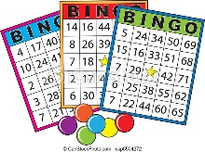  BINGO
SUNDAY | MONDAY | TUESDAY | WEDNESDAY | THURSDAY | FRIDAY | SATURDAY
7th  10:45 – 12pm  Lutheran Church service DVD in the Edwards Rec Room    1:30 – 3:30pm    Come Experiment with Dakota | 8th ^{Kings Birthday}  ^{Public Holiday}  10:30 – 11:30am  Chair Exercises  11:00 – 11:30am Seated Soccer    1:30 – 3:00pm    Indoor Bowls  3:30 – 4:30pm  Mingle with Maxine – Piano Concert | 9th  10:30 – 11:00am    Short Walking Group (weather permitting)  11:00 – 11:30am    1:1 Footy Tipping  1:30- 3:30pm    Let’s create for Philippines Independence Day | 10th  10:30 – 11:30am  Chapel  1:30 – 3:00pm  BINGO  3:00 – 3:30pm  Book Club | 11th  9:30 – 10:00am  Long Walking Group (weather permitting)  10:30 – 11:30am  Scenic Bus Trip  10:30 – 11:00am  Chair Exercises  11:00 – 11:30am  Newspaper Reading  2:00 – 3:00pm  Anne Battams Community Singalong in the Chapel | 12th  10:30 – 11:30am  Let’s Get Trivial!  1:30 – 3:30pm    Come & Celebrate National Philippines Independence Day  2:30 – 3:15pm  Loxton Lutheran School Worship Service | 13th  10:45 – 11:15am  Chair Exercises  11:15 – 12pm    Balloon Tennis  1:30 – 3:30pm  BINGO
SUNDAY | MONDAY | TUESDAY | WEDNESDAY | THURSDAY | FRIDAY | SATURDAY
14th  10:45 – 12pm  Lutheran Church service DVD in the Edwards Rec Room  1:30 – 3:30pm    Reminiscing on days gone by… | 15th  ^{World Elder Abuse Day}  10:00 – 11:30am  Resident and Representatives Meeting  1:30 – 3:00pm  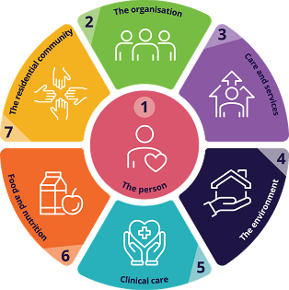  The Gold Standard: What Good Care looks like to you  3:30 – 4:30pm  Mingle with Maxine – Games Afternoon | 16th ^{Men’s Probus}  10:30 – 11:00am  Short Walking Group (weather permitting)  11:00 – 11:30am  1:1 Footy Tipping  1:30 – 3:30pm  Come whip up a storm with Dakota in the Chapel Kitchenette – today we’re making Chocolate Brownies!! | 17th  10:30 – 11:30am  Chapel  1:30 – 3:00pm  BINGO  3:00 – 3:30pm  Book Club | 18th  9:30 – 10:00am  Long Walking Group (weather permitting)  10:30 – 11:00am  Chair Exercises  10:30 – 11:30am  Scenic Bus Trip  11:00 – 11:30am  Newspaper Reading  2:00 – 3:00pm  Anne Battams Community Singalong in the Chapel | 19th  10:30 – 11:30am    Let’s Get Trivial!  1:30 – 3:30pm  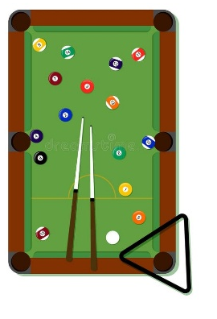  Happy Hour in the Edwards Rec Room | 20th  10:45 – 11:15am  Chair Yoga  11:15 – 12pm  Mini Golf  1:30 – 3:30pm  BINGO
SUNDAY | MONDAY | TUESDAY | WEDNESDAY | THURSDAY | FRIDAY | SATURDAY
21st  10:45 – 12pm  Lutheran Church service DVD in the Edwards Rec Room  1:30 – 3:30pm    Mindfulness Colouring with Dakota | 22nd  10:30 – 11:30am  Quick Quiz!  11:00 – 11:30am    Topical Bible Studies with Pastor Mat Eckermann  1:30 – 3:00pm  Magic Memories  3:30 – 4:30pm  Mingle with Maxine – Piano Concert | 23rd  10:30 – 11:00am  Short Walking Group (weather permitting)  11:00 – 11:30am  1:1 Footy Tipping  1:30 - 3:30pm  We’re all a bit mad here, so come and join us for an afternoon creating hats for our mad hatters tea party! | 24th  10:30 – 11:30am  Chapel  1:30 – 3:00pm  BINGO  3:00 – 3:30pm  Book Club | 25th  10:30 – 11:00am  Chair Exercises    11:00 – 11:30am  Newspaper Reading  11:00-1:00pm  Lunch at The Local  2:00 – 3:00pm  Anne Battams Community Singalong in the Chapel | 26th  9:30 – 10:00am  Long Walking Group (weather permitting)  10:30 – 11:30am Loxton RSL Visit  10:30 – 11:30am  Let’s Get Trivial!  1:30 – 3:30pm    Mocktail Making Afternoon  2:30 – 3:15pm  Loxton Lutheran School Worship | 27th  10:45 – 11:15am  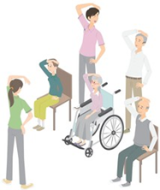  Chair Exercises  11:15 – 12pm    Mini-Basketball  1:30 – 3:30pm  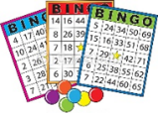  BINGO
SUNDAY | MONDAY  🌿 Find Your Joy 🌿  There’s Something Here at Riverview for Everyone  Did you know there are many lifestyle opportunities available for you to enjoy outside of our leisure and lifestyle program?  You might like to:  ☕ Find a quiet spot in the garden to chat and share a cuppa with a friend  🎲 Play a board game  🧩 Work on a puzzle  🎵 Listen to your favourite music  🎬 Watch a movie  📚 Relax in our cosy reading nook  🎱 Enjoy a game of pool  🏓 Have fun with table tennis  🏒 Try air hockey  Your Enjoyment Matters !!  If something interests you — or if you’re looking for something different —  please speak with one of our friendly team members.  We’re here to support you in finding activities that bring comfort, connection and joy. | TUESDAY
28th  10:45 – 12pm  Lutheran Church service DVD in the Edwards Rec Room  1:30 – 3:30pm    Games Afternoon | 29th  10:30 –11:00am  Chair Exercises  11:00 – 11:30am    Magnetic Darts  1:30 – 3:00pm  Loxton’s History Sure Ain’t Boring  3:30 – 4:30pm    Mingle with Maxine – Piano Concert | 30th  10:30 – 11:00am  Short Walking Group (weather permitting)  11:00 – 11:30am  1:1 Footy Tipping  1:30 – 3:00pm    Paint n’ Sip

