SUNDAY | MONDAY | TUESDAY | WEDNESDAY | THURSDAY | FRIDAY | SATURDAY
31st August  10:45 – 12pm  Lutheran Church Traditional Service DVD in the Edwards Rec Room  Happy hour at LUNCH  1:30 – 3:30pm  Games Afternoon |  | 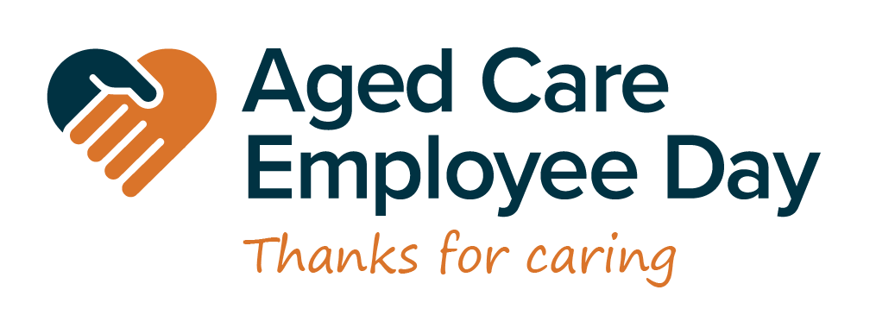 |  | 31st July  10:30 – 11:30am  A visit to Loxton Library  2:00 - 3:00pm    Anne Battams Community Singalong | 1st  9.00 -11.30am  Pancake Morning Tea & Scattegories  1:30 – 3:30pm    Newspaper Reading & Discussions | 2nd  10:45 – 12pm  Chair Exercise & Balloon Tennis    1:30 – 3:30pm  BINGO
3rd  10:45 – 12pm  Lutheran Church Traditional Service DVD in the Edwards Rec Room  Happy hour at LUNCH  1:30 – 3:30pm  Games Afternoon | 4th  10:30 – 11:30am  Chair Exercises & Seated Soccer  1:30 – 3:00pm  The Price is Right Game  3.30 – 4.30pm  Maxine on the piano | 5th  10:30 – 11:30am  Chair Exercises & Quoits  1:30- 3:30pm  Memory Lane Crosswords   | 6th  10:30 – 11:30am  Chapel  1:30 – 3:00pm  BINGO    3:00 – 3:30pm  Book Club | 7th  Jean for Genes Day  Aged Care Employee Day  10:30 – 11:45am  Card Making &  Aged Care Employee Day Presentation  2:00 - 3:00pm  Anne Battams Community Singalong | 8th  10:30 – 11:30am  Let’s Get Trivial!  1:30 – 3:30pm    Magic Memories | 9th  10:45 – 12pm  Chair Exercises & Mini Basketball  1:30 – 3:30pm  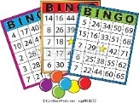  BINGO
10th  Arts on Terrace  10:45 – 12pm  Lutheran Church Traditional Service DVD in the Edwards Rec Room  1:30 – 3:30pm  Bus Drive Around Town | 11th  10:00 – 11:30am  Resident & Representative’s Meeting  1:30 – 3:00pm  Crosswords & Word Games  3.00-3.30pm  Book Club | 12th  10:30 – 11:30am  Chair Exercises & Indoor Bowls  1.30 – 3:30pm    Monthly Birthday Party Celebrations | 13th  10:30 – 11:30am  Chapel  1:30 – 3:00pm  BINGO    3:00 – 3:30pm  Book Club | 14th  11.00am-1.00pm  Lunch at The Local  2:00 - 3:00pm    Anne Battams Community Singalong | 15th  10:30 – 11:30am  Let’s Get Trivial!  1:30 – 3:30pm    Pampering &  Relaxation Afternoon | 16th  10:45 – 12pm  Chair Exercises & Mini-Golf  1:30 – 3:30pm    BINGO
17th  Book Week  10:45 – 12pm  Lutheran Church Traditional Service DVD in the Edwards Rec Room  Happy hour at LUNCH  1:30 – 3:30pm  Movie Afternoon | 18th  Book Week  10:30 – 11:30am  Yarn a Lot  1:30 – 2.30pm  Sentimental Journey Concert  3.30 – 4.30pm  Maxine on the piano | 19th  Book Week  Musical Day  11:30 – 2:30pm  A visit to the High School to see the musical Hello Dolly!  1.30pm – 3.30pm  The Sound of Music in the Rec Room | 20th  Book Week  Loxton Lutheran School Book Week Parade  10:30 – 11:30am  Chapel  1:30 – 3:00pm    BINGO  3:00 – 3:30pm  Book Club | 21st  Book Week  Daffodil Day  10:30 – 11:30am  Craft with Dakota    2:00 - 3:00pm  Anne Battams Community Singalong | 22nd  Book Week  10:30 – 11:30am  Let’s Get Trivial!  1:30 – 3:00pm  RV Revellers with John Kindness | 23rd  Book Week  10:45 – 12pm  Chair Exercises & Ten Pin Bowling  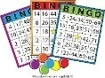  1:30 – 3:30pm  BINGO
24th  10:45 – 12pm  Lutheran Church Traditional Service DVD in the Edwards Rec Room  1:30 – 3:30pm  Bus Drive Around Town | 25th  10:30 –11:30am  Chair Exercises and JBall Hockey  1:30 – 3:30pm    Games, Brain Boosters & Crosswords | 26th  National Dog Day  10:30 – 11:30am  Walking Group  With a Furry Friend  (Weather permitting)    1:30- 3:30pm  Cooking Class | 27th  10:30 – 11:30am  Chapel  1:30 – 3:00pm    BINGO  3:00 – 3:30pm  Book Club | 28th  10:30 – 11:30am  Scenic Bus Trip  2:00 - 3:00pm    Anne Battams Community Singalong | 29th  10:30 – 11:30am  Let’s Get Trivial!  1:30 – 3:30pm    Antiques Roadshow | 30th  10:45 – 12pm  Chair Exercises & Magnetic Darts  1:30 – 3:30pm  BINGO  

